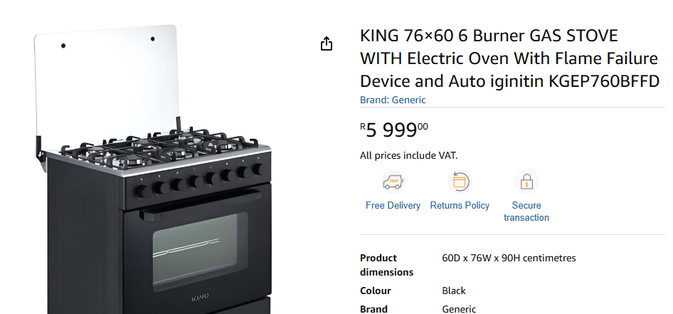

Customer ordered this from Amazon. She got KGP760B. Has no FFD and not on the data base. This one is on the database and has the FFD

From Anazon
No FFD and not on the safe appliance data base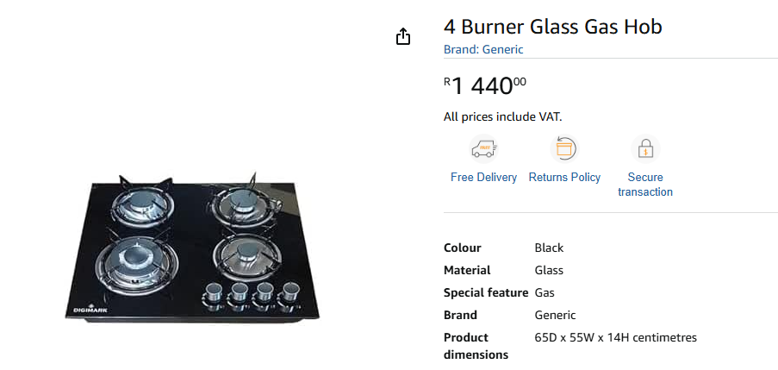Fron Makro

Not on safe list
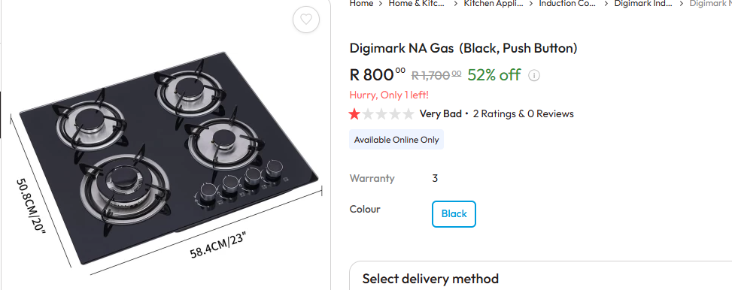

From Leroy Merlin
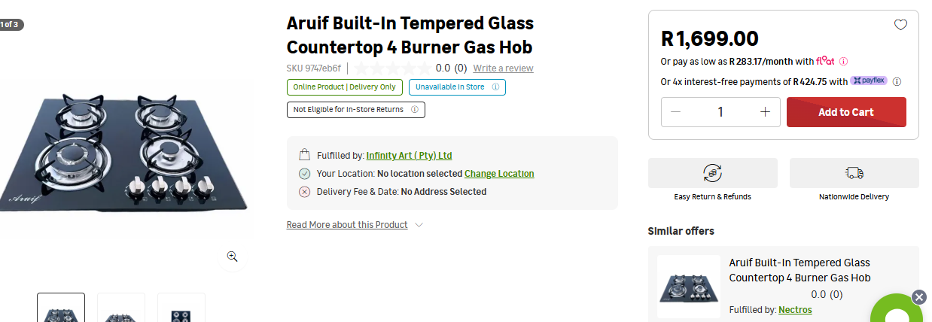

Not on list

Take a lot
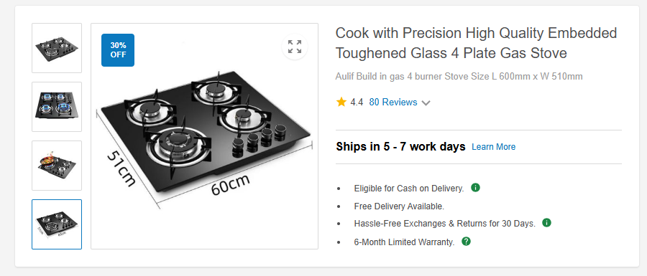
Not on list

On Amazon

